Chapter 3, Problem 90.

Calculate v_{s} for the transistor in Fig. 3.126, given that v_{o} = 4 V, β = 150, V_{BE} = 0.7V.

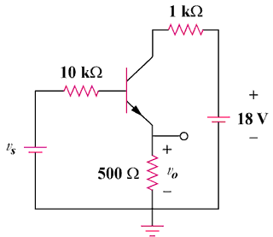

Figure 3.126
For Prob. 3.90.

